Surviving for Dummies
Introduction
“It is not the strongest or the most intelligent who will survive but those who can best manage change.” - Charles Darwin. What if you and a friend decided you wanted to take a daring trip somewhere up north in a hot air balloon. It doesn’t help that your friend is afraid of heights and you’re claustrophobic. What could go wrong? Your balloon could get to hot and catch on fire. The fire could spread lower and lower until you could feel the heat on the back of your neck. Your balloon could burn away and all that’s left is you, your friend, and the basket that was once attached to the balloon. You could fall to your death but luckily hit a body of water instead, but that could never happen right? This is the main idea for our website. This main idea kind of gives you a heads up about the plot of my website. It makes you question ways to survive if something as tragic as that could happen. In my web design class, I was required to code a whole entire website I the span of 12 weeks. I was required to Photoshop my items to look more realistic and neat. While reflecting on my overall experience in this class, I will outline the immense stress we went through when creating this website. I was greatly tiring, but came out perfect in the end. It was worth it in the end and I am proud of our creation. This website reflects 3 ways of how my partner and I would survive which is by hunting and gathering, staying hydrated, and protecting each other.
Index
Our first page is reflects the rest of the website. It shows you the items that we have and how we ended up in that scenario. The overall purpose of this site is to show one how to survive I ever stranded on an island or a forest. Our story started off with my partner and me in a blimp that was on first. This scene took some time because we were debating on how we became stranded in the northern peninsula with a blimp, specifically how we got onto land with a blimp that was supposedly on fire. We decided to say that we jumped off of the blimp and swam to land. During the story we list our items which are a pocket knife, a filtering straw, and a teddy bear. I feel that we just rushed on the last item, but we made it work and it surprisingly became useful in our story. We chose the color choices to match the forest, and for our font we chose Times New Roman which is a serif font. Our logo is the northern peninsula to match the theme of our website. The overall theme of the website goes with a story plot very well I believe. We added a basket of the items we had with use to give the audience and idea of what we dealt with. The video that we made gives our website a clear image of what’s going on with the website. The website has a good amount of character and meaning with every page one goes to.
Pocket knife
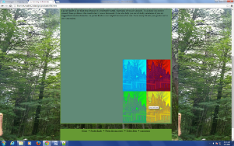
Our first item talks about its use in the forest. The pocket knife was one of our biggest resources out of all three items. With the pocket knife we could make weapons out of sticks and use it as defense and hunting. We added a marquee on this page to give the audience what we had to deal with. The sliding marquee was probably favorite code. I find it cool that this code actually interacts with the person viewing that page. The code that I struggled with was probably adding the video to our page. First we had to edit the video on Vimeo, download it, and then code it to show up on our website. I’m not the best when it comes to coding so that is most likely why I had trouble doing that.

Filtering Straw
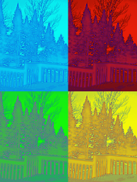
For our second item we explained the reasons behind bringing it. The Filtering Straw is used to filter out water that we drink so that the water can be pure and not contaminated. My photo edit was probably the pop art edit. In the pop art I got to duplicate my photo in 4 different ways and colors. The Photoshop edit that caused me the most problems was the “Perfect Portrait” edit. This edit caused me the most problems because I had to do a lot of work to make the picture look how I wanted it to look. I had to use the spot healing tool, at a reflection and choose what type of reflection I wanted to be on it. I also had to add a filter, which made my photo look harsh and unappealing.
Teddy Bear
For our last object we choose to bring a teddy bear. Now I know what you're thinking “what use can a teddy bear be to someone in a forest”. Well surprisingly it could help a lot. Even though this was a hard object to fit into our criteria we made it work. The NETS benchmark of Creativity and innovation was met because my partner and I picked an object that was hard to work with and made an original idea out of it. With the teddy bear we decided to use it as a storage unit, meaning that we would store our goods like a pocket knife and a filtering straw in it and use it as a rucksack without the strings as we travel through the forest. One specific lesson that was a time issue for me was the coding issue. We had to create the object whether it was a photo shopped image or a video and then code it so that I worked when we went onto our website. If it didn't work we had to look over the code and find out what went wrong. Including the code looked like something a 3 year old would type if you left your computer unattended, it was pretty complex. The lesson that was most time consuming was the hyperlink. I still get confused while hyper linking because I have to add the image or video and then add on a <a href…> and then add on the website where I found it on. most of the time i keep forgettin the </a> at the end of the code and then get frustrated as to why it isn't working, is just a bunch of silly mistakes with me.
Webmaster
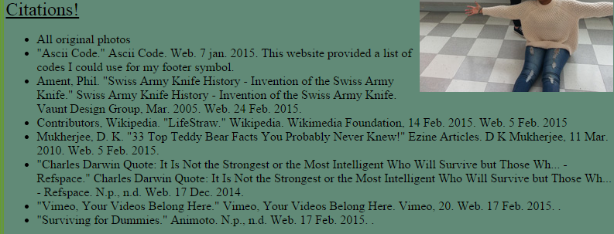
Our acknowledgment page is probably my favorite page because everything is organized and fills up the entire page. On this page we added our personal story. we talked about our goals in life like what school we wanted to go to after high school and our life long goals. We added a chart of our achievements including certificates and computer tools we used throughout having web design and computer technology class. An important feature on this page are the citations. We cited mostly every website and tool that we used whilst making the website. The most useful resource was the notepad++. Without that we wouldn't even have a website. The notepad++ gives me the chance to create my own individual website however I want. Not a lot of people my age know how to code a website, and I think that is pretty cool.
Conclusion
The thing that I enjoyed about the web design class was looking at the finished website once it was done. Sometimes it shocks me that I actually know how to make a website at such a young age. Based on teacher, peer, and self-evaluation feedback, I feel that my strengths are photo shopping self-drawn photos on the computer and adding them to specific pages on my website. My weaknesses is learning how to in a certain amount of time. That class goes fast and doesn't wait up for you if you have an issue. I always had a problem with deadlines, but my partner always helps me out so I’m always on time. If I could begin this contest over again and redo my website I would change my items and pick more useful items other than a teddy bear. My partner and I could use this experience in the future if we go into a career field where we have to code websites or if we if we become photographers and have to Photoshop the photos we take. this class added meaning to my life because it makes me want to go into a technology career field and make apps or become a traveling photographer and take pictures to post onto my blog so that it also inspires people. this class benefits me because in the future if my boss or college professor tells me that I need to know how to Photoshop or code a website I’ll already know how to.

